**Datacom Part - FTB-860 (Ethernet Applications)**

**Typical Network Setup**

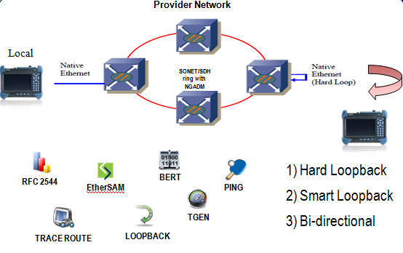

**Bi-Directional Testing (Dual Test Set)**

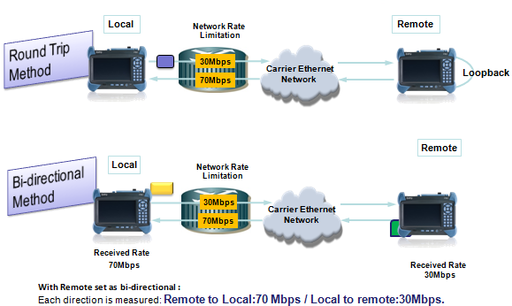

**PART 1: REMOTE UNIT SETTING**

ITU-T Y.1564 EtherSAM Dual Test Set Mode (Bi-Directional Mode)

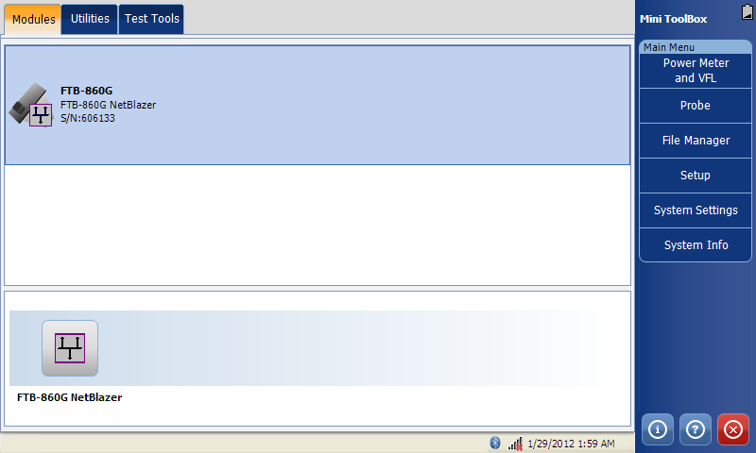

1: Select the FTB-860 NetBlazer to load into the application.

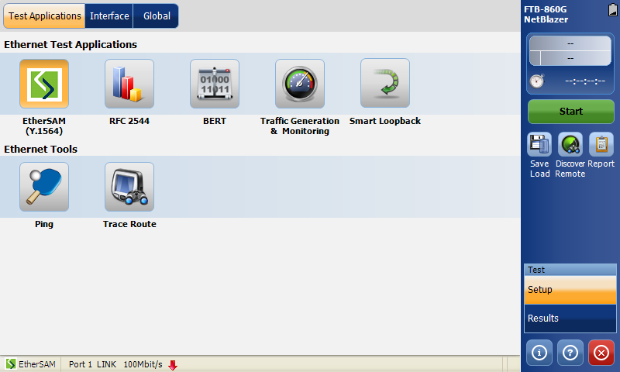

2: Click on the TEST APPLICATION Tab

3: Select desired test application, in this case, click on the EtherSAM (Y.1564) to select the test.

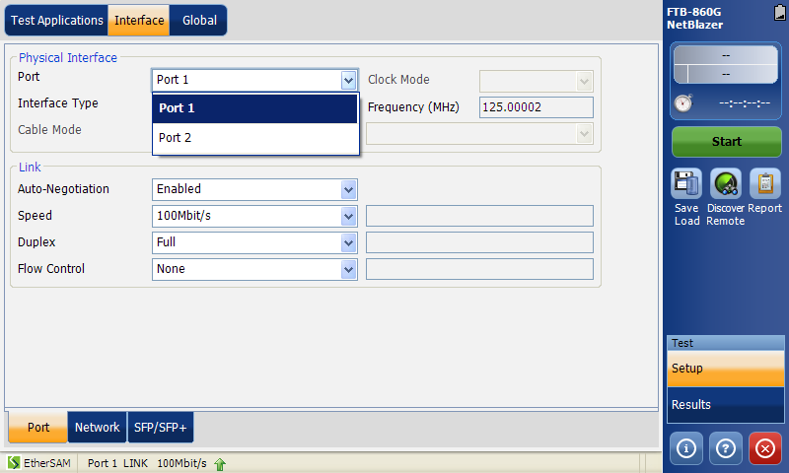

4a: Click on the INTERFACE Tab.

4b: Click on the Port tab. (Bottom)

4c: Select Port 1 or Port 2 as test port from the pull down list.

Network tab (Bottom) for IP address configuration.

**Ensure the link up at the remote side when connected to Ethernet NE. (bottom status bar)

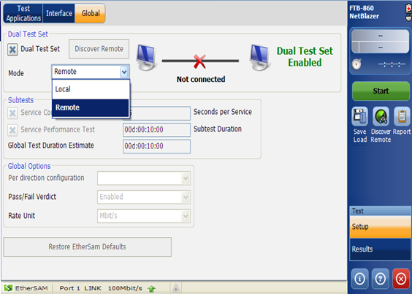

5a: Click on the GLOBAL tab.

5b: Checked the Dual Test Set box

5c: Select “Remote” from the pull down menu “Mode”.

**PART 2: LOCAL UNIT SETTING**

EtherSAM Dual Test Set



1: Select the FTB-860 NetBlazer to load into the application.

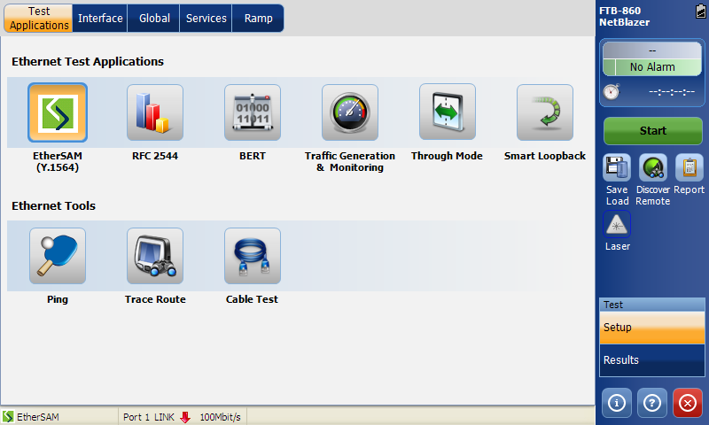

2: Click on the TEST APPLICATION Tab

3: Select desired test application, in this case, click on the EtherSAM (Y.1564) to select the test.

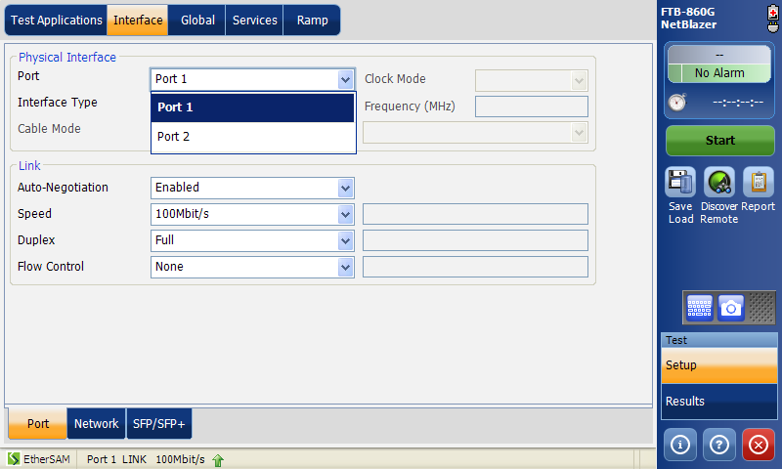

4a: Click on the INTERFACE Tab.

4b: Click on the Port tab. (Bottom)

4c: Select Port 1 or Port 2 as test port from the pull down list.

**Ensure the link up at the remote side when connected to Ethernet NE. (bottom status bar)

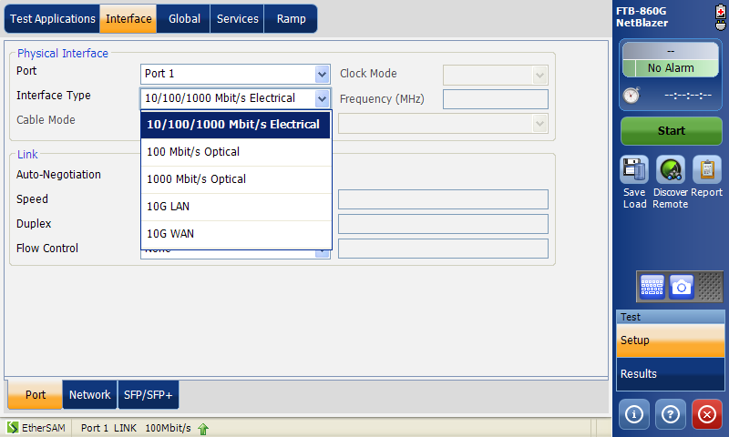

5: Select desired interface type from the pull down list. (Optical or Electrical Interface)

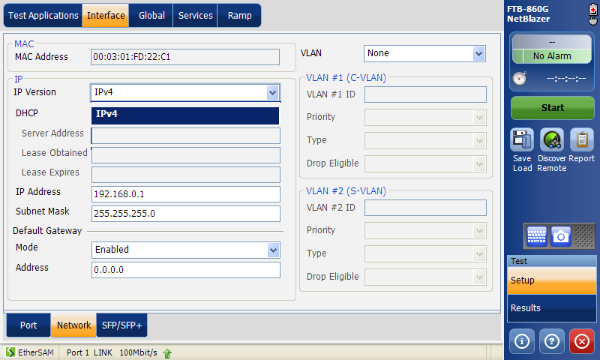

6: Click on the Network tab.

7: Select IP version from the pull down list. (Either IPv4 or IPv6 if applicable)

Then follow by IP Address, Subnet Mask and Default Gateway to test.

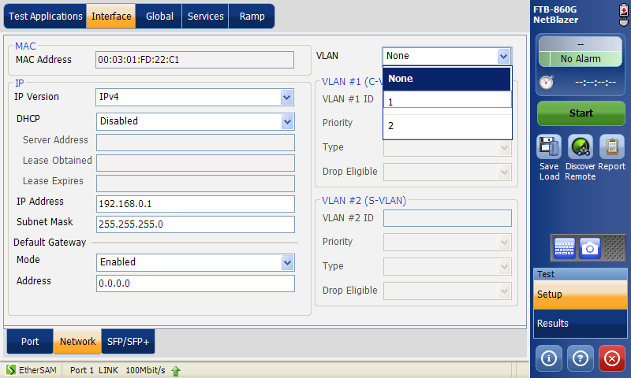

8: Select VLAN if applicable. (Support VLAN Q-in-Q with VLAN ID Priority, Type and Drop Eligible)

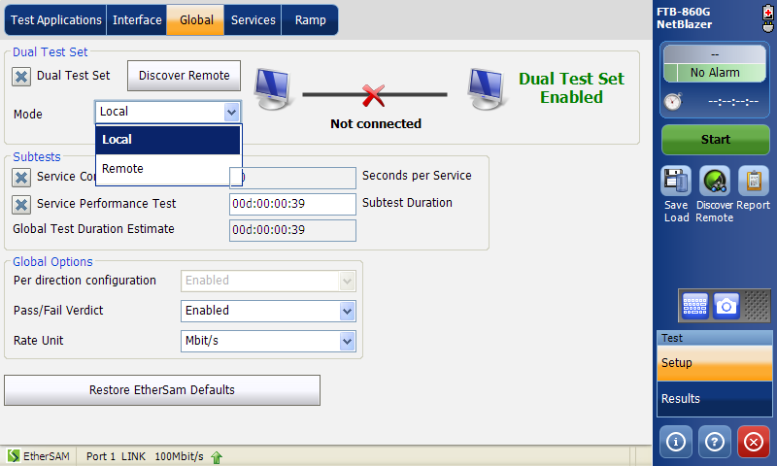

9a: Click on the GLOBAL tab.

9b: Checked the Dual Test Set box

9c: Select “Local” from the pull down list.

9d. Enable the Service Configuration Test and Service Performance Test with the recommended Test duration

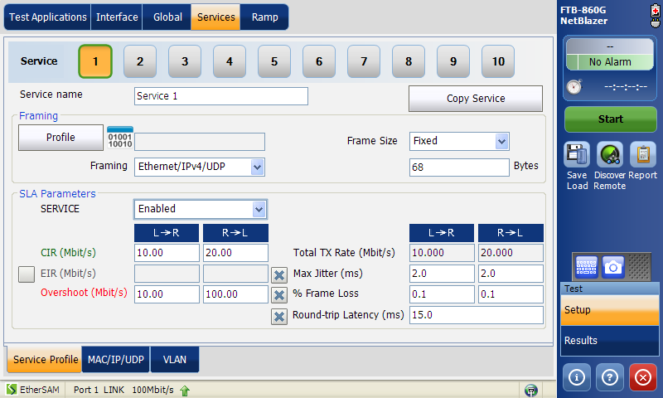

10a: Click on the SERVICE tab.

10b: Select Service to perform configuration setting.

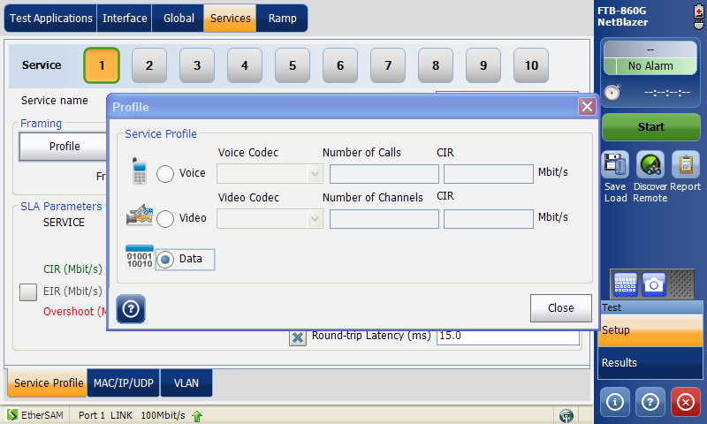

11: Click on Profile to select desired test (Voice, Video or Data) for Service 1

** a) VOICE Codec Supported:

b) VIDEO Codec Supported:

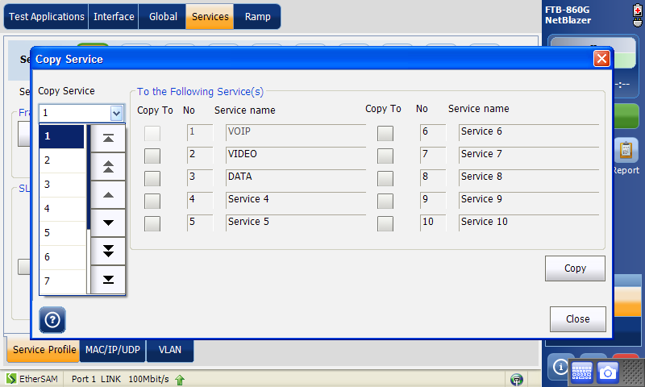

**select Copy Service menu will allow duplicate service configuration to all relevant services.

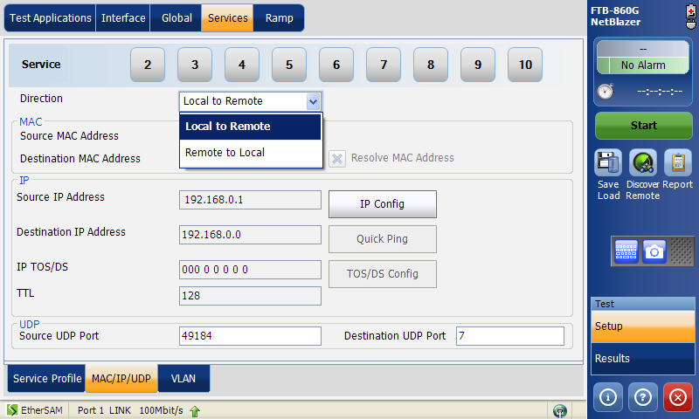

12a: Then click on the MAC/IP/UDP tab

12b: Select the direction of the testing.

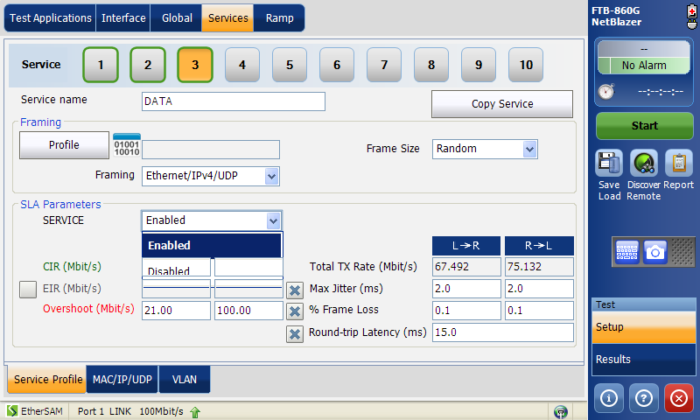

13a: Back to the Service Profile Tab.

13b: Highlight by clicking on the service number.

13c: Then Enable the service if you wish to run the service.

**PART 3: Discovery Remote Mode**

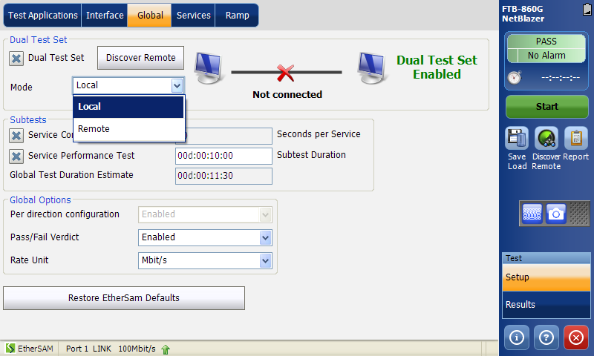

1: To connect to remote unit, on the Local unit, click on the Discovery Remote tab.

** Discover Remote unit menu can be access by shortcut icon on side panel as well.

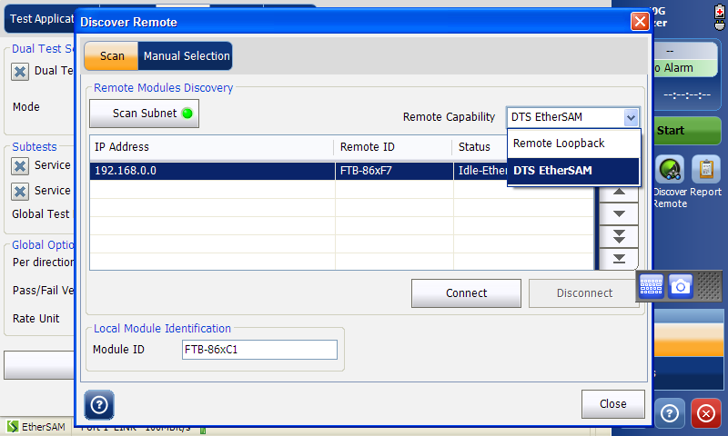

2a: Click on the Scan tab.

2b: Select DTS EtherSAM from the pull down list at the remote capability selection.

2c: Turn on the Scan Subnet by clicking on the tab.

2d: IP address of the remote unit will appear. Select the IP address.

2e: After select the IP address, click on the Connect tab.

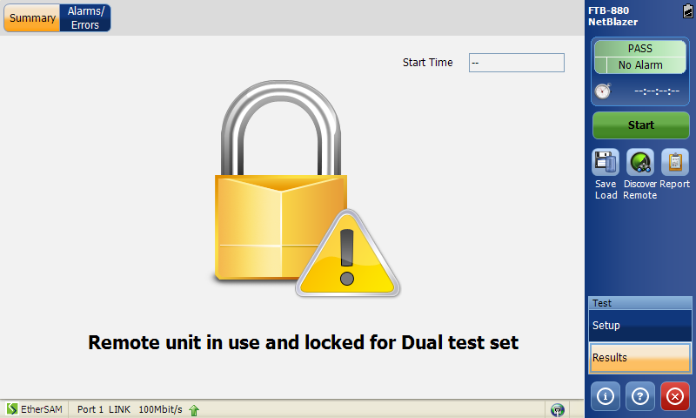

At the Remote unit, once the unit is connected to local unit, the screen will appeared as above. No more changes can be done in Remote Unit.

**Start Testing**

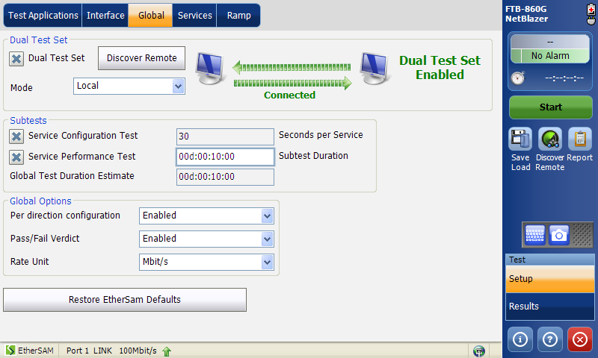

3: Ensure the link is UP.

4: Click on the START button.

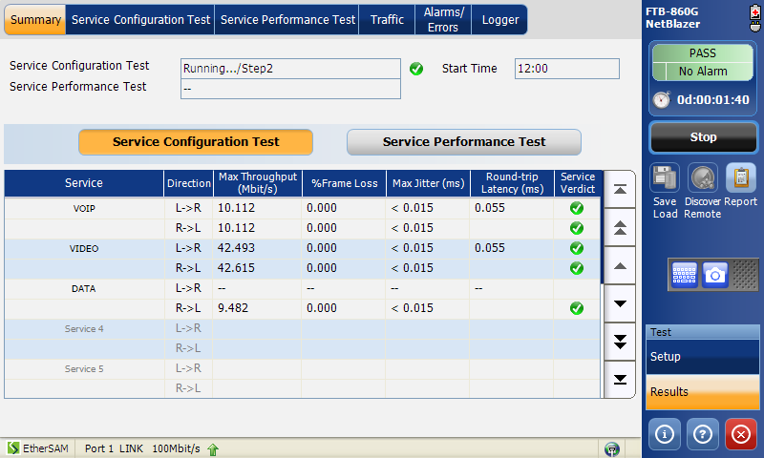

5: Test start running, and will automatically go to Results tab

6: Click on the alarm indicator will enlarge the screen to show the indicator as below step 7

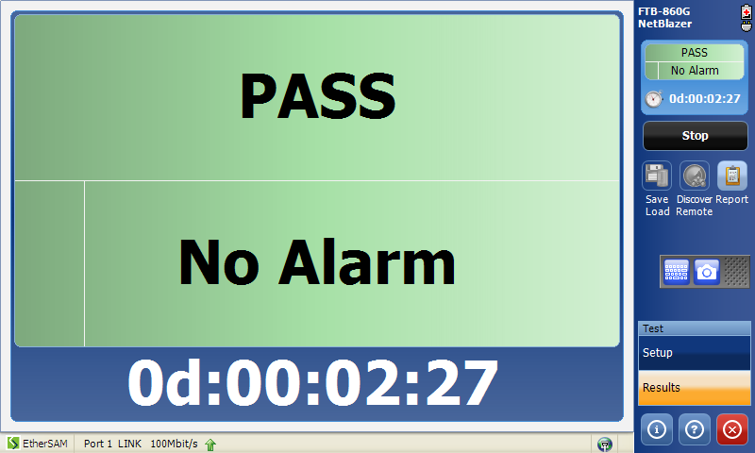

7: Alarm indicator menu, to resume back to result screen by clicking the indication.

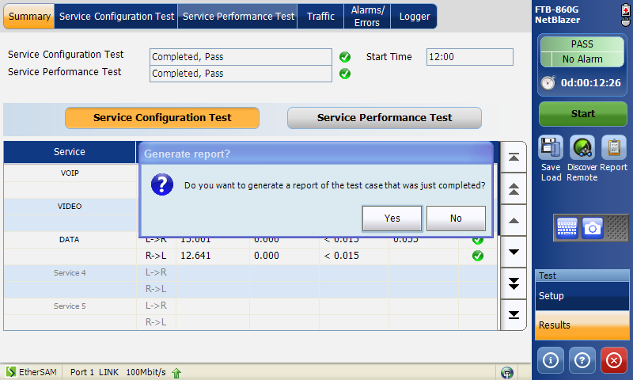

7: After test completed, window pop up to request to generate report.

8: Manually, report can be generated by clicking on the Report icon. (side panel)